**CS 550 PROJECT 5**

Name: CHI CHIEH WENG

Email: wengchic@oregonstate.edu

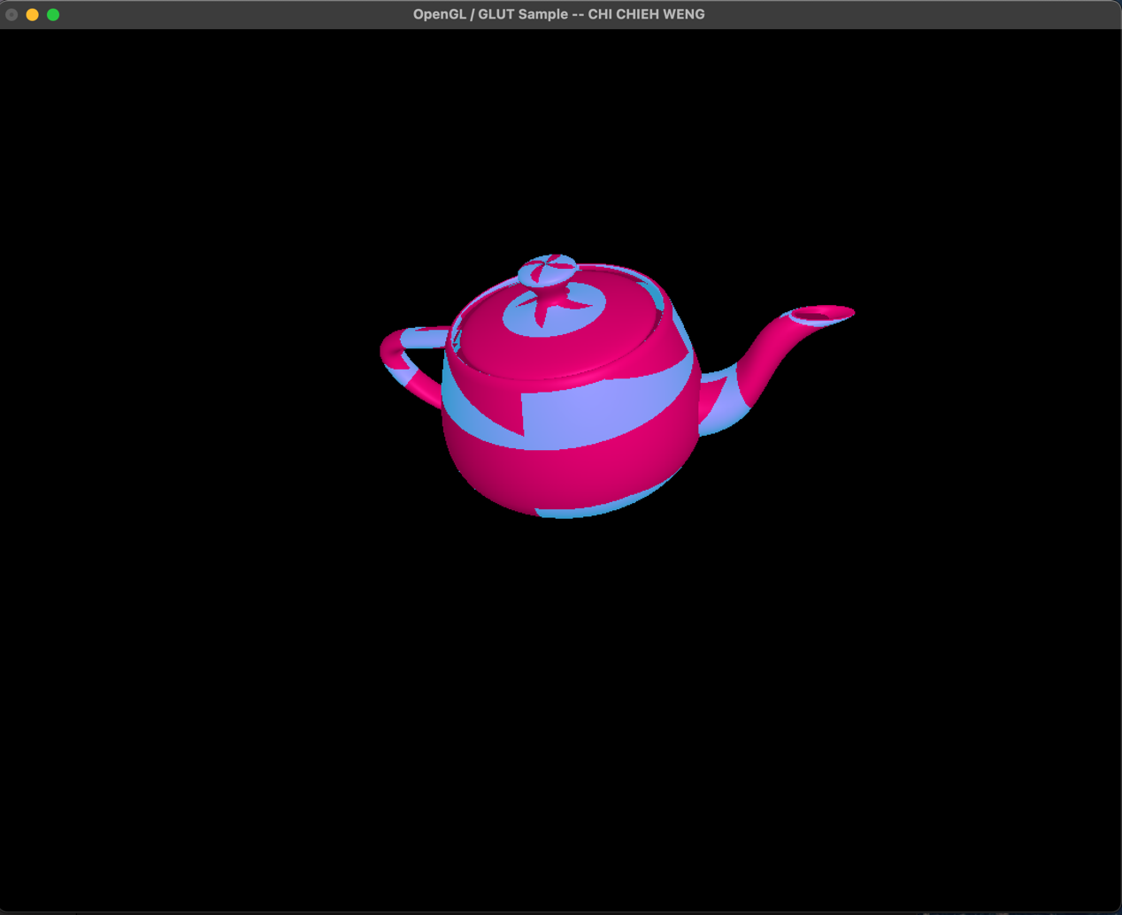

Video lnik:

https://media.oregonstate.edu/media/t/1_meej5urj